BUG REPORT

1.Defect ID: BUG-001
Bug Title: Refreshing the state details page opens the Home page
Severity: Major
Priority: High
Environment: Windows 11, Google Chrome
Steps to Reproduce
- Open the application.
- Select any state from select a state dropdown
- Stay on the selected state
- Refresh the page.
Expected Result
The same state's details page should open after refreshing.
Actual Result
After refreshing, the application opens the Home page instead of the selected state's page.
Suggested Fix
The application should stay on the same state page after refresh.

Screenshot 1: showing the selected state details
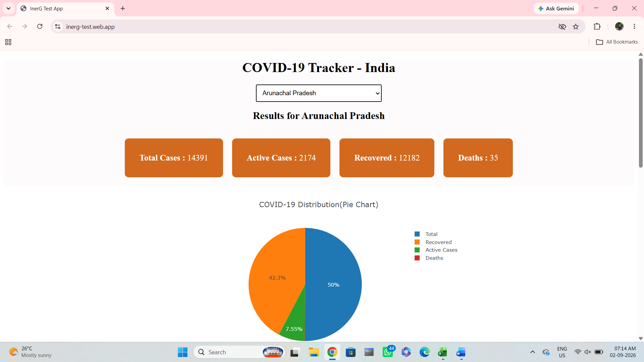

Screenshot2:During refreshing it goes to the homepage and clears data

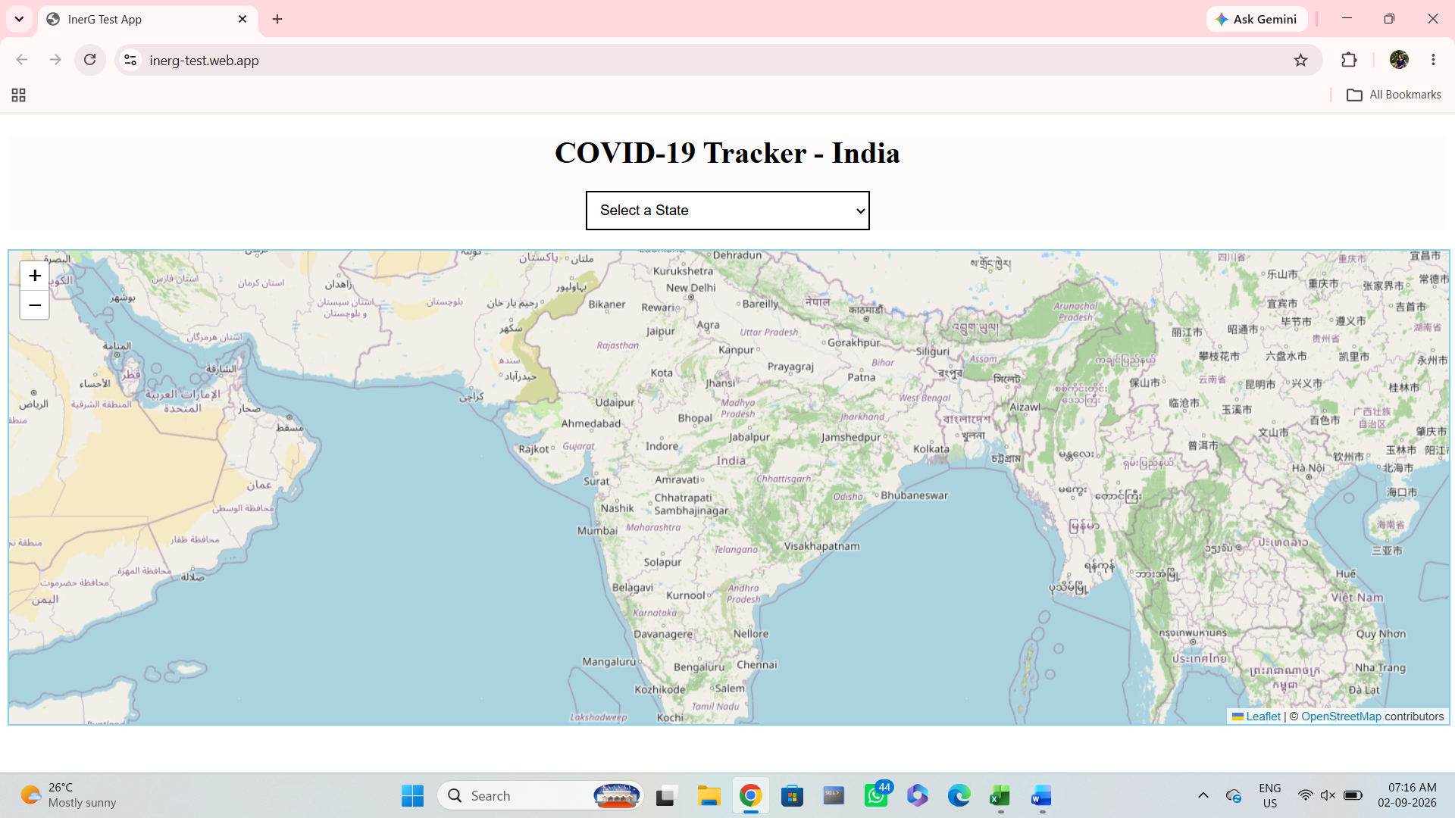

1.Defect ID: BUG-002
Module: State Details
Bug Title: Back and Forward buttons are not available on the state details page
Severity: Minor
Priority: Medium
Environment: Windows 11, Google Chrome
Steps to Reproduce
- Open the application.
- Go to the State Details page.
- Open any state's details.
Expected Result
Back and Forward buttons should be available to make navigation easier.
Actual Result
Back and Forward buttons are not available on the page.
Suggested Fix
Add Back and Forward navigation buttons to improve user navigation.
Screenshot showing no forward or backward Navigation buttons
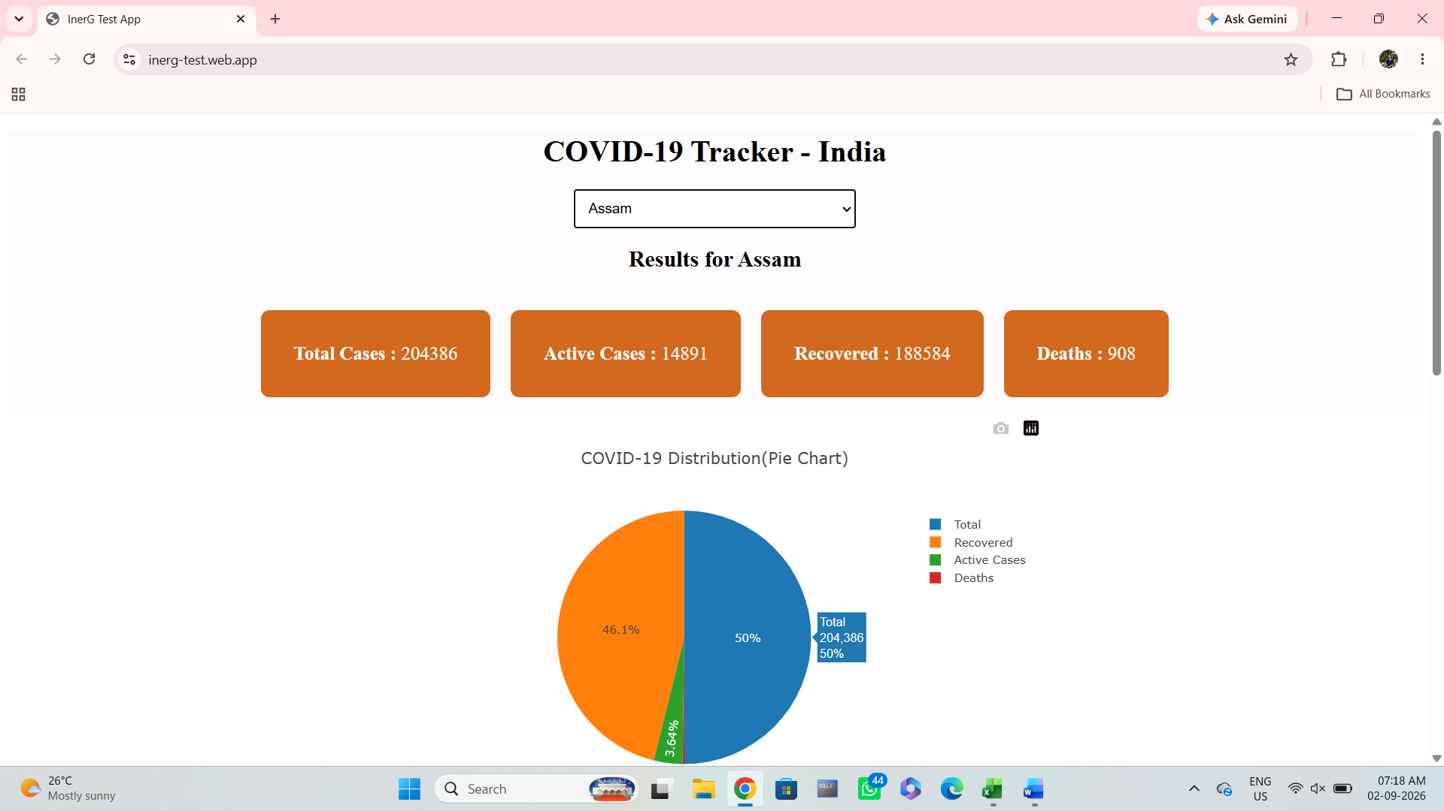

Defect ID: BUG-003
Module: Mobile View
Bug Title: Page elements are not aligned properly on mobile devices
Severity: Minor
Priority: Medium
Environment: Samsung a04s Android, Google Chrome
Steps to Reproduce
- Open the application on a mobile phone.
- Navigate through different pages.
- Observe the page layout.
Expected Result
All text, buttons and images should be properly aligned.
Actual Result
Some elements are not aligned properly and a few sections overlap on the screen.
Suggested Fix
Adjust the page layout for mobile screens so that all elements are displayed properly.

Screenshot showing mobile view with misalignment and cant able to see many text .
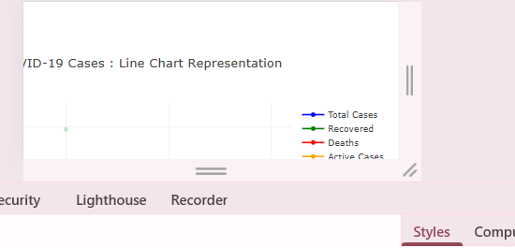

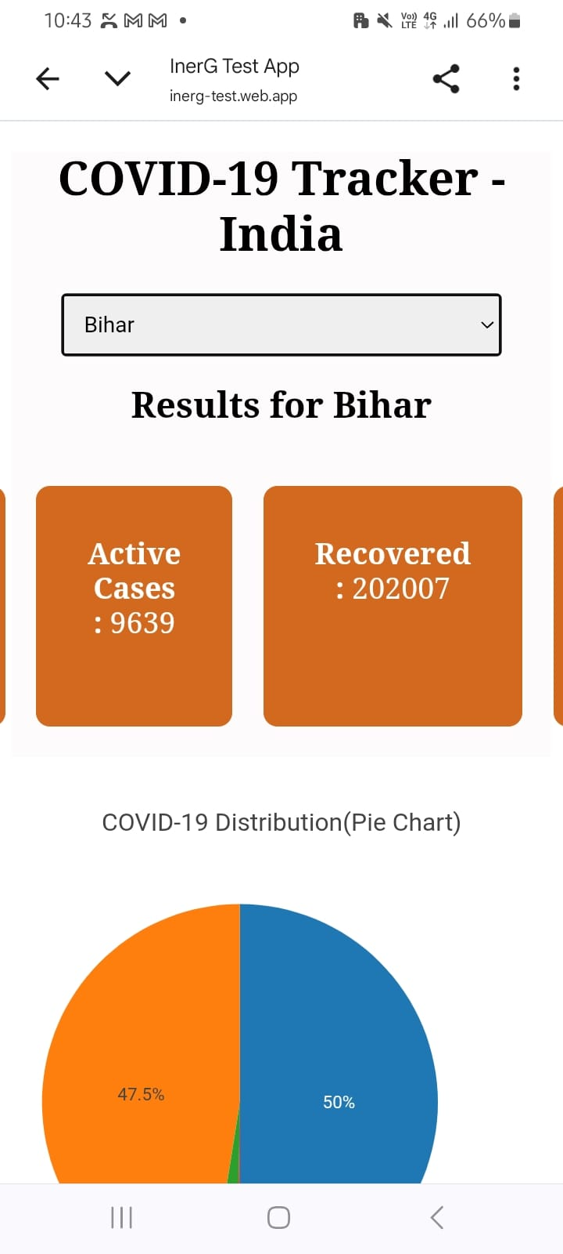

Defect ID: BUG-004
Module: Dashboard
Bug Title: Line graph is displayed without graph lines
Severity: Major
Priority: High
Environment: Windows 11, Google Chrome
Steps to Reproduce
- Open the application.
- Go to the Dashboard.
- Check the line graph section.
Expected Result
The line graph should display the COVID-19 data properly.
Actual Result
The graph is displayed, but the lines are missing.
Suggested Fix
Check why the graph lines are not showing and display the data correct

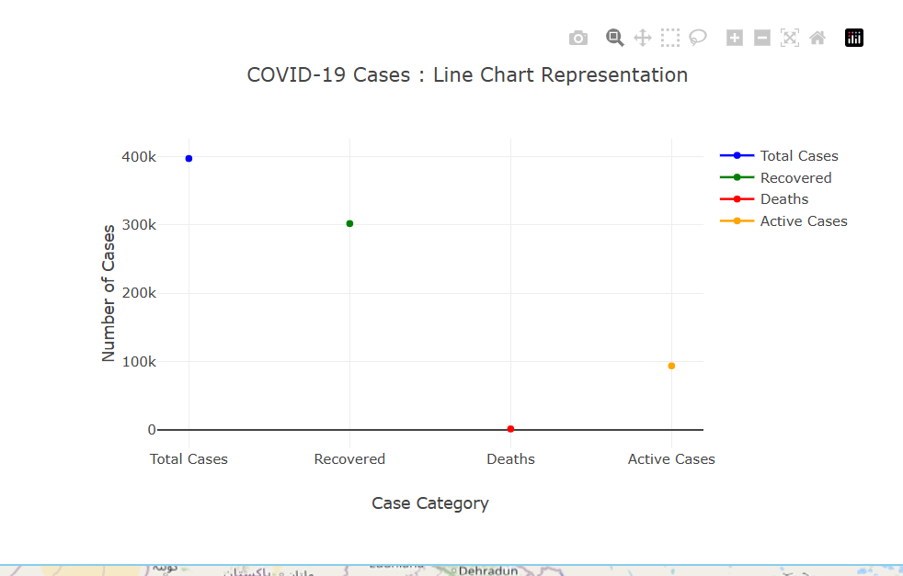
Defect ID: BUG-005
Module: Dashboard
Bug Title: Total reported cases count is incorrect
Severity: Critical
Priority: High
Environment: Windows 11, Google Chrome
Steps to Reproduce
- Open the application.
- Go to the Dashboard.
- Note the values of Total Reported Cases, Active Cases, Recovered Cases and Death Cases.
- Add the Active, Recovered and Death counts.
Expected Result
The Total Reported Cases should be equal to the sum of Active, Recovered and Death cases.
Actual Result
The Total Reported Cases value is different from the calculated total.
Suggested Fix
Check the calculation and display the correct total number of reported cases.

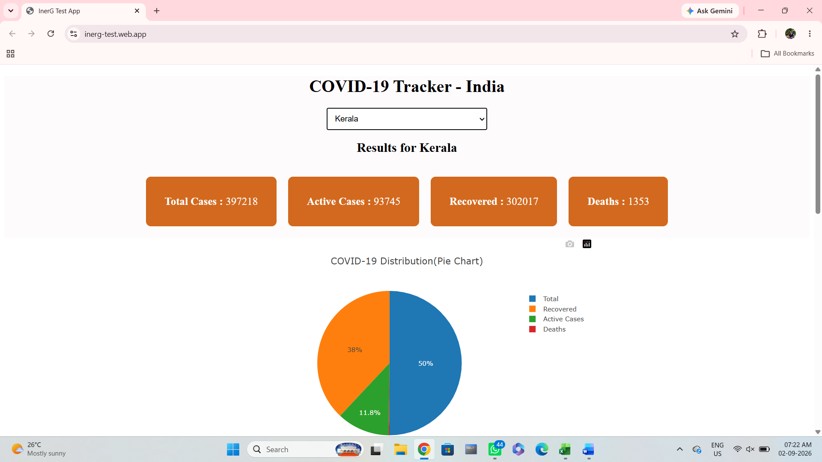
Screenshot showing incorrect total cases

